Hackathon 4 - Picture the Planet
Film: “Support your club. Not every new kit.” · SDG 13 · 8 video-shots + 2 text cards

How to regenerate
- Video shots 1–8: workflow picture-the-planet_minimax_h3_t2va.json (MiniMax H3 text-to-video, run on RunningHub). Settings for every shot: 16:9, 960 × 544, 24 fps, sigma_points 20, seed 1. Prompt goes in T2VA Text Encode, duration and size in T2VA Target, seed in Dual Sigma Sampler.
- Text cards 9-10: picture-the-planet_z-image-turbo_card2_closing (Y-Z-Image-turbo-workflow, run on runninghub). Settings for every shot: 1344 × 768, seed 1.
- Same look: every video prompt ends with the same style line: Cinematic, desaturated cool colors, subtle film grain, soft natural light, smooth 24fps.
- Duration: clips were trimmed or sped up in CapCut. The duration column is the length in the final film. Frames are taken from the final film (watermark cropped out at 115%).

# | Duration | Frame | Our description | Prompt | Seed
1 | ~7 s | 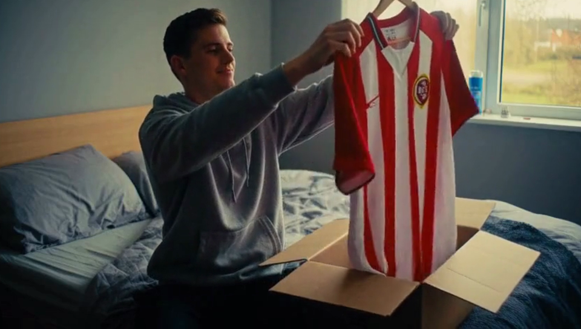 | The story starts in a happy, familiar moment: a young fan unpacks his brand-new striped club shirt in warm daylight and proudly holds it up. This is the feeling our audience knows.  He hangs the shirt in his wardrobe. It is the only shirt among empty hangers. We wanted the emptiness to be obvious, so the overflowing wardrobe later hits harder. | 7-second video, two shots with one hard cut at 4 seconds. Shot 1, 0 to 4 seconds: medium shot, static camera, warm afternoon daylight from a window, a young Dutch man in his early 20s with short dark hair and a plain grey hoodie sits on the edge of his bed in a small cozy bedroom, he pulls a new red and white vertically striped football shirt out of an open cardboard box and holds it up in front of him with both hands, his eyes fixed on the shirt, head turned slightly to the side, smiling proudly while he admires it, plain shirt with no logos and no text, soft rustling of packing paper. Shot 2, 4 to 7 seconds: the same bedroom, static camera, frontal view of an open white wardrobe, his hand in the grey hoodie sleeve hangs the same red and white vertically striped football shirt on a wooden hanger on the rail, it is the only shirt in the wardrobe, many empty hangers and lots of empty space around it, the hand leaves the frame and the shirt sways gently, soft clack of a hanger and quiet room ambience. Cinematic, desaturated cool colors, subtle film grain, soft natural light, smooth 24fps. | Seed: 1
2 | ~2.5 s (sped up 1.8×) | 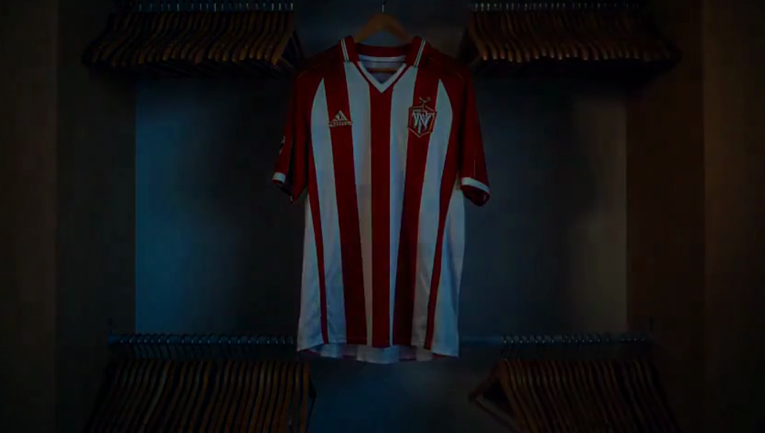 | Time-lapse: the lonely shirt hangs while the light changes from afternoon sun to blue evening to night. It shows that time passes and a new season is coming. | integrated_multimodal_description: Cinematic, live-action, a static shot of an open wardrobe with a single red and white striped football shirt hanging alone between many empty wooden hangers. Time-lapse: the light in the room changes quickly from warm afternoon sun to cool evening blue to dark night, shadows sweep fast across the wardrobe and the wall, day and night flicker by several times. The shirt and the wardrobe stay completely still. The camera does not move. It ends in darkness, lit only by cool night light.  overall_soundscape: A steady ticking clock, soft muffled sounds of days passing, quiet room ambience fading into night silence.  non_diegetic_music: N/A | Seed: 1
3 | ~2.5 s | 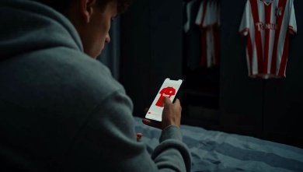 | A new season: at night he scrolls a web shop and taps “buy” on next season’s shirt without thinking, out of habit. The old shirt still hangs in the background. | 4-second video, one continuous shot, static camera, close-up over the shoulder of a young man in a plain grey hoodie sitting on his bed in a dark bedroom at night, he holds a smartphone, the screen glow lights his hand and fingers, his thumb scrolls slowly through an online shop and stops at a large photo of a new red football shirt with white sleeves and a big button, then his thumb taps the button once, quickly and casually, out of habit, a small green checkmark appears on the screen, in the blurred dark background an open wardrobe with a single red and white striped shirt hanging alone, plain shirts with no logos and no text, soft scrolling sounds, a soft tap and a short cheerful notification ping, then quiet night silence. Cinematic, desaturated cool colors, subtle film grain, soft natural light, smooth 24fps. | Seed: 1
4 | ~2.5 s | 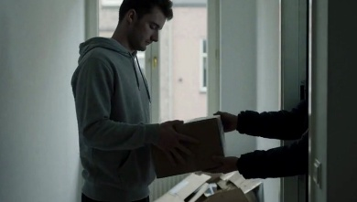 | Another parcel arrives. He takes it from the delivery person without any excitement: buying has become routine. | 4-second video, one continuous shot, static camera, medium shot in a narrow apartment hallway in cool grey morning light, a young Dutch man in his early 20s with short dark hair and a plain grey hoodie opens the front door, the arm of a delivery person in a dark jacket hands him a cardboard parcel through the doorway, the delivery person's face is not visible, he takes the parcel with both hands without enthusiasm, tired neutral expression, eyes on the parcel, torn packaging from earlier deliveries lies in the corner of the hallway, plain packaging with no logos and no text, a doorbell ring, the door opening, rustling cardboard. Cinematic, desaturated cool colors, subtle film grain, soft natural light, smooth 24fps. | Seed: 1
5 | ~3.5 s (sped up 1.7×) | 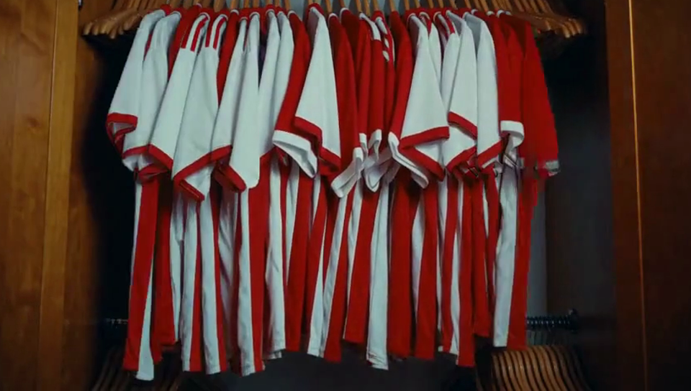 | Time-lapse: shirts appear one by one until the wardrobe overflows and spills towards the camera. Pings and doorbells speed up. We zoom into the pile until red and white fills the screen. | 6-second video, one continuous shot, static camera, close frontal view straight into an open light wooden wardrobe, warm honey-colored wooden side walls, a plain white back panel, two horizontal chrome rails, an upper rail and a lower rail, on each rail wooden hangers are bunched together on the left side and on the right side with an empty space in the middle, a single red and white vertically striped football shirt with a white V-neck collar hangs alone on a wooden hanger in the center of the upper rail, warm afternoon sunlight, a hand in a grey hoodie sleeve hangs a new red football shirt with white sleeves next to it and leaves the frame, then time-lapse: the light flickers quickly between day and night, and one by one new red and white football shirts appear on all the empty hangers of both rails, faster and faster, until every hanger is full, then shirts pile up at the bottom of the wardrobe until it is completely overflowing and shirts spill out towards the camera, the wardrobe and the camera stay completely still, plain shirts with no logos, no badges and no text, a ticking clock speeding up, notification pings and doorbell rings repeating faster and faster, rustling fabric, ending with a soft heavy thud. Cinematic, desaturated cool colors, subtle film grain, soft natural light, smooth 24fps. | Seed: 1
6 | ~3.5 s (sped up 1.5×) | 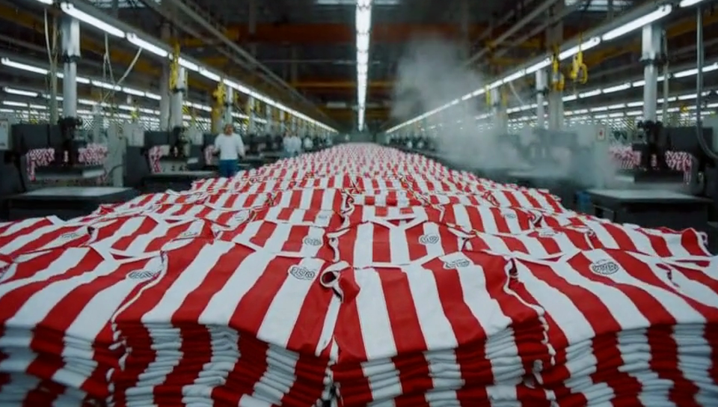 | Match cut: the pile becomes a pile in a factory. The camera pulls back to reveal an endless hall full of identical shirts. One wardrobe is part of mass production. | 5-second video, one continuous shot, the camera starts on an extreme close-up of a messy heap of crumpled red and white striped football shirts filling the entire frame, then slowly pulls back and rises, revealing that the heap is one of countless piles of red and white shirts inside an enormous textile factory hall, endless rows of stacks and industrial heat press machines stretching into the distance, small blurred anonymous workers in the far background, harsh fluorescent light, cold hazy air, plain shirts with no logos, no badges and no text, rhythmic heavy thumping of heat press machines, hissing steam, echoing factory hall. Cinematic, desaturated cool colors, subtle film grain, soft natural light, smooth 24fps. | Seed: 1
7 | ~3.5 s (sped up 1.25×) | 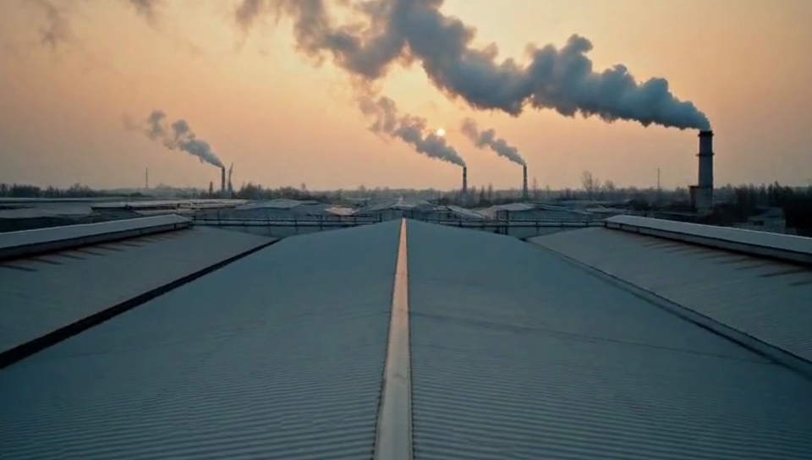 | The camera follows the steam up through the factory roof. Outside, chimneys pump smoke into an orange sky: the hidden climate cost of the shirts. | 6-second video, one continuous shot, the camera starts inside an enormous textile factory hall looking over an endless sea of red and white striped shirts under harsh fluorescent light, white steam rises from the machines, the camera follows the rising steam upward to the high ceiling and through a large open roof vent to the outside, then keeps rising and pulls back, revealing the whole grey factory complex from above at dusk, several tall chimneys releasing thick dark grey smoke that billows and spreads across an orange polluted sky, no people visible outside, no signs and no text, the rhythmic thumping of machines fades and becomes muffled, replaced by wind and a deep low industrial rumble. Cinematic, desaturated cool colors, subtle film grain, soft natural light, smooth 24fps. | Seed: 1
8 | ~4.5 s (sped up 1.3×) | 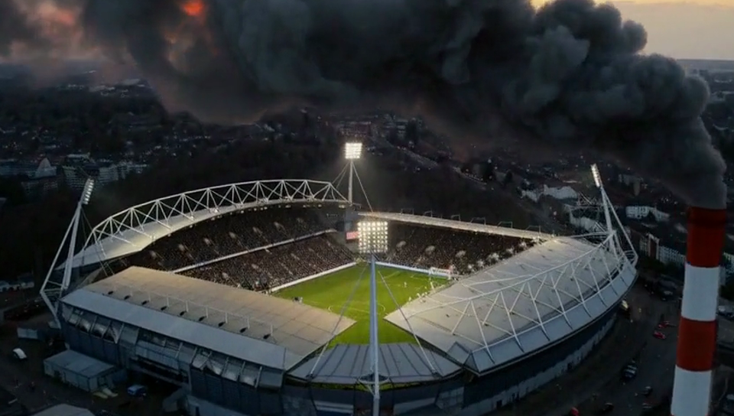 | The smoke drifts over a full stadium. The fans watch the match and don’t notice. The smoke grows and swallows everything until the screen is black. It brings the problem back to football. | 8-second video, one continuous shot, the camera starts high in the sky above a grey factory at dusk where thick dark grey smoke billows from tall chimneys, the wind carries the smoke cloud away across the orange polluted sky and the camera travels along with it, flying over a city, the smoke drifts over a large generic football stadium full of people with its floodlights on and a match being played on the green pitch below, the crowd does not notice the smoke above them, the smoke cloud grows darker and heavier over the stadium roof, then the camera slowly pushes forward into the thick dark smoke cloud until the smoke fills the entire frame and everything fades to complete black, no club names, no advertising, no logos and no text, deep low rumble and wind, distant crowd murmur from the stadium that slowly fades away, ending in complete silence. Cinematic, desaturated cool colors, subtle film grain, soft natural light, smooth 24fps. | Seed: 1
9 | ~3.5 s | 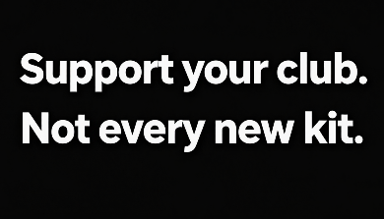 | Fact card on black: the facts behind the story, with a personal quote. | Minimalist title card, pure black background, exactly two lines of bold white sans-serif text, perfectly centered in the middle of the image. The first line reads "Support your club." and the second line directly below reads "Not every new kit." Each line appears only once, there are exactly two lines in total. No other text, no repeated words, no symbols, no logos, nothing else in the image. | Seed: 1
10 | ~2.5 s | 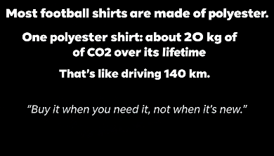 | Closing card: the message the audience should remember and can act on. | Minimalist title card, pure black background, perfectly centered in the middle of the image. At the top, exactly three lines of bold white sans-serif text. The first line reads "Most football shirts are made of polyester." The second line directly below reads "One polyester shirt: about 20 kg of CO2 over its lifetime." The third line directly below reads "That's like driving 140 km." Below that, after some empty space, one smaller line of light grey italic serif text in quotation marks that reads "Buy it when you need it, not when it is new." Each line appears only once, there are exactly four lines in total. No other text, no repeated words, no symbols, no logos, nothing else in the image. | Seed: 1

Edit notes
- Shots 1–5: hard cuts.
- 5 → 6: zoom into the pile (115% → 200%)
- 6 → 7: hard cut
- 7 → 8: fade out from 7 and fade in to 8.
- 8 → 9: zoom on the smoke, fade out.
- 9: short fades on black.
- 10: fades in
- Sound: only the audio generated by MiniMax H3 in ComfyUI, volumes evened out in capcut.

